**SQL QUERIES**

**1. Views**

**1] retrive the name and id of insurance**

CREATE VIEW INSURANCE1_VIEW AS

SELECT i_id, i_name

FROM insurance;

select * from INSURANCE1_VIEW ;

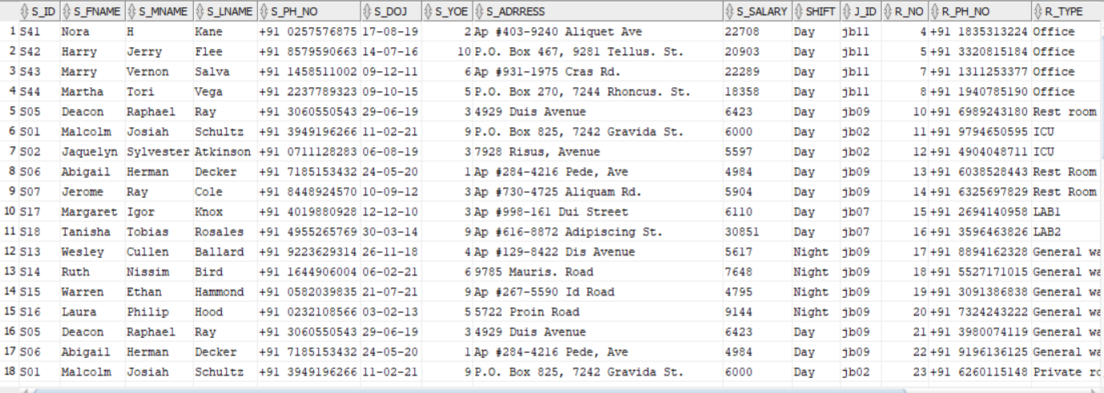

(49 rows)

**2] display the room numbers to which staff Molly is appointed**

CREATE VIEW medTest5 as

SELECT R_NO

FROM room r, staff s

WHERE r.s_id=s.s_id and s.S_Fname like '%Molly%';

select * from medTest5 ;

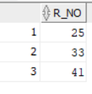

**3] patient who will be treated by MacKenzie**

CREATE VIEW DoctorPatient as

SELECT P_Fname,P_Lname

FROM patient p, prescription pr

WHERE p.P_ID=pr.P_ID

and pr.s_id in(select pr.s_id

from staff s, prescription pr

where pr.s_id=s.s_id AND s.S_Fname like '%MacKenzie%');

select * from DoctorPatient ;

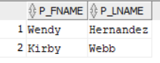

**4] staff who has salary greater than 5000**0

CREATE VIEW staffSal1 as

SELECT s_id,S_Fname,S_Lname

FROM staff s

WHERE s.S_Salary > 50000;

select * from staffSal1 ;

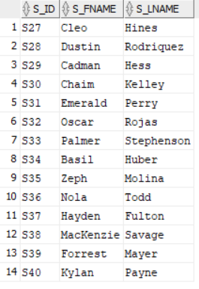

5**] display the patient record id to whom nurse mallcom was allocated**

CREATE VIEW PatientNurse as

SELECT rec_id

FROM patient_record pa, Room r

WHERE pa.R_NO=r.R_NO

and r.s_id in(select r.s_id

from staff s, Room r

where r.s_id=s.s_id AND s.S_Fname like '%Malcolm%');

select * from PatientNurse ;

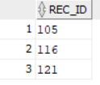

**6] retrive all the names of staff who are Radiologist**

CREATE VIEW JOBTS as

SELECT s_id,S_Fname,S_Lname

FROM staff s , jobtype j

WHERE s.J_id= j.J_id and j.J_name like '%Radiologist%';

select * from JOBTS ;

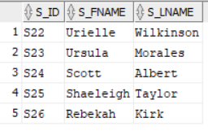

7] **staff who will prescribe medicine Lovastatin**

CREATE VIEW DoctorPrescription1 as

SELECT S_Fname,S_Lname

FROM staff s, test t

WHERE s.s_id = t.s_id

and t.PR_ID in(select t.PR_ID

from test t, prescription pr

where t.PR_ID=pr.PR_ID AND pr.Med_name like '%Cephalexin%');

select * from DoctorPrescription1;

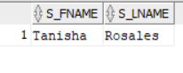

8] **display the patients full name who have taken Lic insurance**

CREATE VIEW patientINS as

SELECT P_Fname,P_Lname

FROM insurance i, patient p

WHERE i.i_id=p.i_id and i.i_name like '%LIC%';

select * from patientINS ;

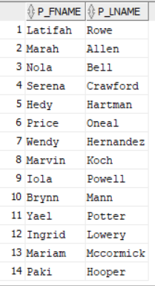

9**] display the tests conducted by staff of name Micah**

CREATE VIEW staffTest1 as

SELECT T_name

FROM test t, staff s

WHERE t.s_id=s.s_id and s.S_Fname like '%Micah%';

select * from staffTest1 ;

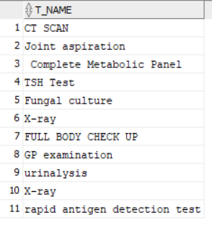

10**] display the tests after which Amlodipine Besylate medicine needs to be taken**

CREATE VIEW medTest2 as

SELECT T_name

FROM test t, prescription pr

WHERE t.PR_ID=pr.PR_ID and pr.Med_name like '%Amlodipine Besylate%';

select * from medTest2 ;

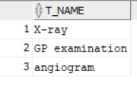

**2. Sub Queries**

**1]display the 3rd lowest salary of the staff.**

SELECT S_Salary FROM staff a1 WHERE 3-1= (SELECT COUNT(DISTINCT S_Salary) FROM staff a2 WHERE a2.S_Salary > a1.S_Salary);



**2] Find the patient who paid highest when admitted**

SELECT * FROM patient_record pr

WHERE pr.amount>=ALL(SELECT patient_record.amount FROM patient_record);

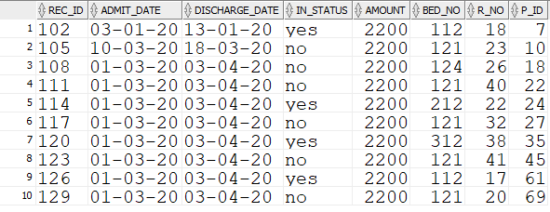

3] **Find the patient who paid least when admitted**

SELECT * FROM patient_record pr

WHERE pr.amount<=ALL(SELECT patient_record.amount FROM patient_record);

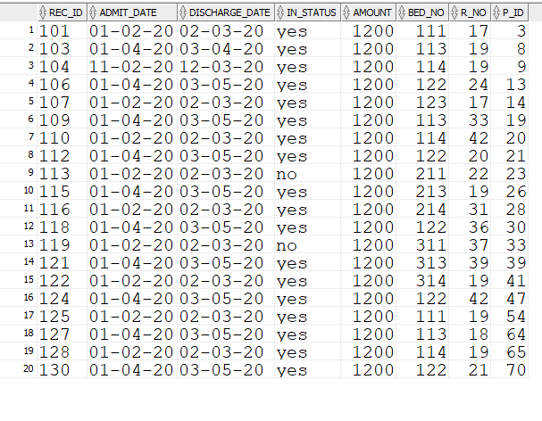

**4] Display the test details which is the costliest**

SELECT * FROM test t

WHERE t.t_amt>=ALL(SELECT test.t_amt FROM test);

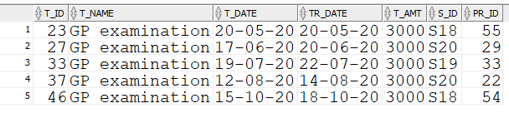

5**] Display the test details which is the cheapiest**

SELECT * FROM test t

WHERE t.t_amt<=ALL(SELECT test.t_amt FROM test);

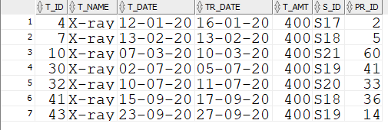

**6] display med name , patient id and dose prescribed when dose>470**

select med_name, p_id,pr_dose

from prescription

where p_id IN (select p_id from patient where pr_dose>470)

order by (pr_id);

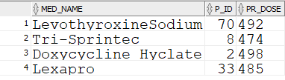

**7]Display the patient id and first name if thier insurance amount is greater than 50000**

select p_id, p_fname

from patient

where i_id IN (select i_id from insurance where i_amount < 50000)

order by (p_id);

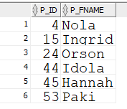

**8]Display patient id and name admitted in general ward room number 19**

select p_id,p_fname

from patient

where p_id IN (select p_id

from patient_record

where r_no=19);

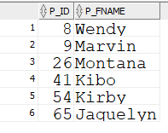

**9]Display patient id and name who where tested by staff member having id S21**

select p_id,p_fname

from patient

where p_id IN (select p_id

from prescription

where pr_id IN (select pr_id

from test

where s_id='S21'));

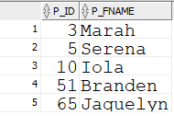

10]Display staff is and name who joined since 2019

select s_id,s_fname

from staff

where s_doj>'01-jan-2019';

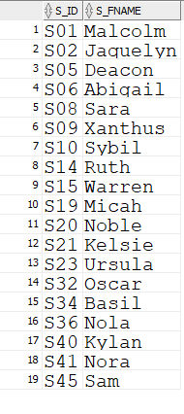

**11)Retrieve name of lab technician who diagnosed 'Nola Bell"**

SELECT s_fname, s_lname

FROM staff s, jobtype jd

WHERE s.j_id=jd.j_id and jd.j_name = 'Lab technician' and s_id IN (SELECT s_id

FROM patient p, prescription pp

WHERE p.p_id = pp.p_id and p_fname= 'Nola' and p_lname= 'Bell');



**12)Retrieve patient's name who have been insured by LIC health insurance cover**

SELECT p.p_fname, p.p_lname

from patient p

where p.i_id IN (select i.i_id

from insurance i

where i.i_name='LIC');

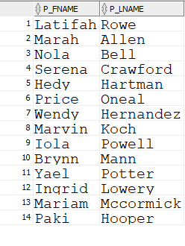

**13)Find the patient id and name and insurance type of the patient with the highest insurance amount.**

select p.p_id,p.p_fname, i1.i_name, i1.i_amount

from insurance i1 ,patient p

where i1.i_id=p.i_id and NOT EXISTS(select * from insurance i2

where i2.i_amount > i1.i_amount);



**14] display the amount charged by staff named Noble to the patient**

SELECT amount

FROM patient_record pa,room r

WHERE pa.R_NO=r.R_NO

and r.s_id in(select r.s_id

from staff s, Room r

where r.s_id=s.s_id AND s.S_Fname like '%Noble%');



**15) display staff name who prescibes the medicine 'Carvedilol'**

select s.s_fname

from staff s

where s.s_id IN (select p.s_id

from prescription p

where p.med_name='Carvedilol');

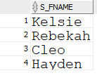

**16)display the shift of the staff who treats patients of age 20**

Select SHIFT

from staff s , prescription pr

where s.s_id=pr.s_id

and pr.P_ID in(select pr.P_ID

from prescription pr, patient p

where pr.P_ID=p.P_ID and p.P_AGE=20);



**17)display patient name who has been prescibed the medicine 'Diovan HCT'**

select p1.p_fname

from patient p1

where p1.p_id IN (select p.p_id

from prescription p

where p.med_name='Diovan HCT');



**18)display the insurance id of the patient who is treated by a staff with more than 4 years of experience**

Select i_id

from patient p , prescription pr

where p.P_ID=pr.P_ID

and pr.P_ID in(select pr.P_ID

from staff s

where pr.s_id=s.s_id and s.S_YOE<3);

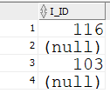

**19)display staff name who handles room number 11**

select s.s_fname

from staff s

where s.s_id in(select r.s_id

from room r

where r.r_no=11);



**20)display the insurance id of the patient who is treated by the staff whose last name is Huber**

Select i_id

from patient p , prescription pr

where p.P_ID=pr.P_ID

and pr.P_ID in(select pr.P_ID

from prescription pr, staff s

where pr.s_id=s.s_id and s.S_Lname like '%Huber%');

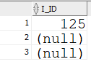

**21)display the test name given by the staff who has qualification in BMLT**

select t.t_name

from test t, staff s

where s.s_id =t.s_id and s.j_id IN(select j.j_id

from jobtype j

where j.qualification LIKE '%BMLT%');

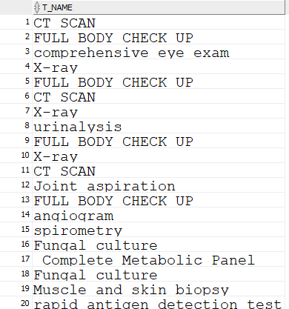

**22)display the years of experince and name of staff who charges amount 2200**

select S_Fname,S_YOE

from staff s,room r

where s.s_id=r.s_id

and r.R_NO in(select r.R_NO

from room r, patient_record pa

where r.R_NO=pa.R_NO and pa.amount= 2200);

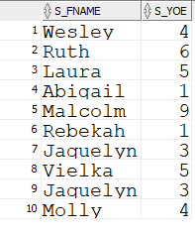

**23)display the jobtype name of the staff who is assigned to room number 26**

select J_name

from jobtype j, staff s

where s.j_id=j.j_id

and s.s_id in(select s.s_id

from room r, staff s

where r.s_id=s.s_id and r.R_NO=26);



**24)display bed number and room number of the patients treated by 'Malcolm'**

select pr.bed_no, pr.r_no

from patient_record pr

where pr.r_no IN (select r1.r_no

from room r1, staff s

where s.s_id=r1.s_id and s.s_fname= 'Malcolm');

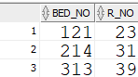

**28)display the job type of the staff who had treated 'Price Oneal'**

select j.j_name

from jobtype j, staff s

where s.j_id=j.j_id and s.s_id in(select pr.s_id

from prescription pr

where pr.p_id IN(select p.p_id

from patient p

where p.p_fname='Price' and p.p_lname='Oneal'));

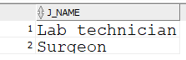

**29)display details of patient who are females and are inpatients.**

select * from patient p1

where exists ( select * from patient p2

where p2.P_Type like '%inpatient%' and p2.P_GENDER like '%female%' and p1.P_GENDER=p2.P_GENDER and p1.P_Type=p2.P_Type );



**3. Different Clauses & Functions**

**1] Display the average salary of all doctors**

select AVG(s.S_Salary) avg_salary,j.J_id

from staff s, jobtype j

where j.J_id=s.J_id and (j.J_name<>'Nurse') and (j.J_name<>'Ward boy') and (j.J_name<>'Lab technician') and (j.J_name<>'Radiologist') and (j.J_name<>'Receptionist')

GROUP BY j.J_id;

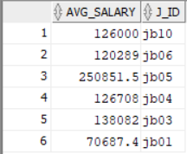

**2] Display the average salary of all staff members**

select AVG(s.S_Salary) avg_salary,jb.J_id

from staff s, jobtype jb

where jb.J_id=s.J_id

GROUP BY jb.J_id;

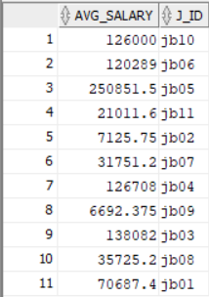

**3] Display total number of tests each patient was prescribed**

select p.P_ID, COUNT(t.T_id)

from Patient p, prescription pr, test t

where pr.P_ID = p.P_ID and pr.PR_ID=t.PR_ID

GROUP BY p.P_ID;

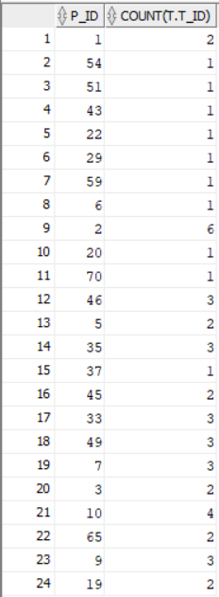

**4] Display number of staff members working for day shift based on their job type**

select COUNT(s.S_id),s.J_id

from jobtype j, staff s

where s.J_id=j.J_id and s.SHIFT='Day'

GROUP BY s.J_id;

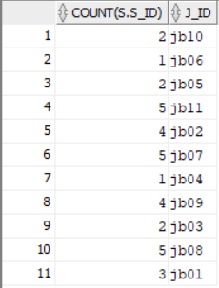

**5] Display for each doctor total number of patients consulted and total insurance amt paid by those patients**

select s.S_id , COUNT(pr.P_id) , SUM(i.i_amount)

from insurance i, patient p, prescription pr, staff s

where pr.p_id=p.P_id and pr.S_id=s.S_id

GROUP BY s.S_id

ORDER BY s.S_id;

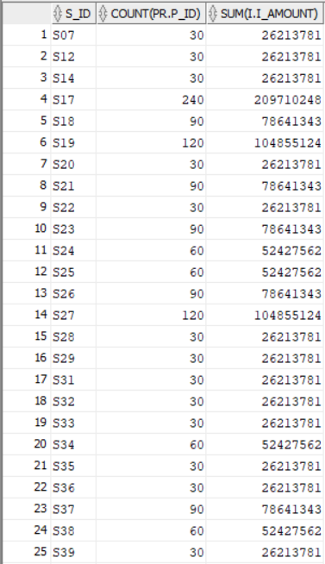

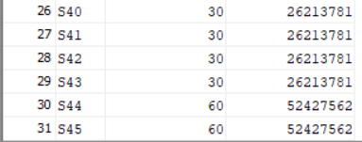

**6] Display the doctors names who have prescribed the patients more than 2 tests**

select s.s_fname , COUNT(t.t_id)

from staff s,test t, prescription pr

where s.s_id=pr.s_id and pr.p_id=t.pr_id

GROUP BY s.s_fname

HAVING COUNT (t.t_id)>=2;

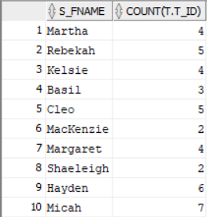

**7] Display Count of how many times each insurance is used by different patients**

select i.i_name, COUNT(p.i_id)

from patient p, insurance i

where p.i_id=i.i_id

GROUP BY i.i_name

HAVING count(p.i_id)>1;

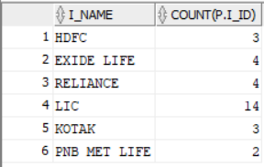

**8] Display names and salary of the staff from highest to lowest years of experience**

select s.s_fname,s.s_salary,s.s_yoe

from staff s

ORDER BY s.s_yoe DESC;

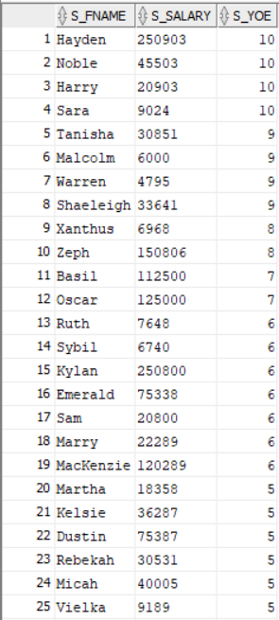

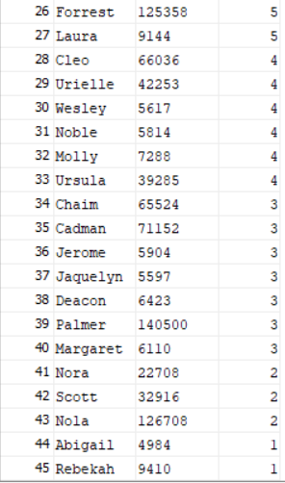

**9] Retrieve the name of the Gynaecologist who has 2 patients.**

select s.s_fname , COUNT(pr.p_id)

from staff s,jobtype j, prescription pr

where s.j_id=j.j_id and j.j_name like '%Gynaecologist%' and s.s_id=pr.s_id

GROUP BY s.s_fname

HAVING COUNT (pr.p_id)>1;



**10] Display number of days each ward was occupied chronologically**

select distinct r.r_no, SUM(pr.discharge_date - pr.admit_date)days_occupied

from patient_record pr, room r

GROUP BY r.r_no

ORDER BY r.r_no;

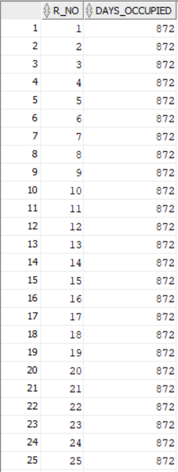

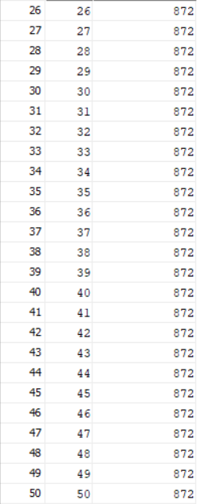

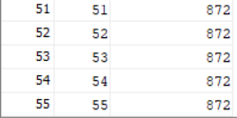

**4. MULTIPLE JOINS**

**1.Retrieve staff details of the nurse/ward boy assigned to the room**

SELECT *

FROM staff

NATURAL JOIN room;

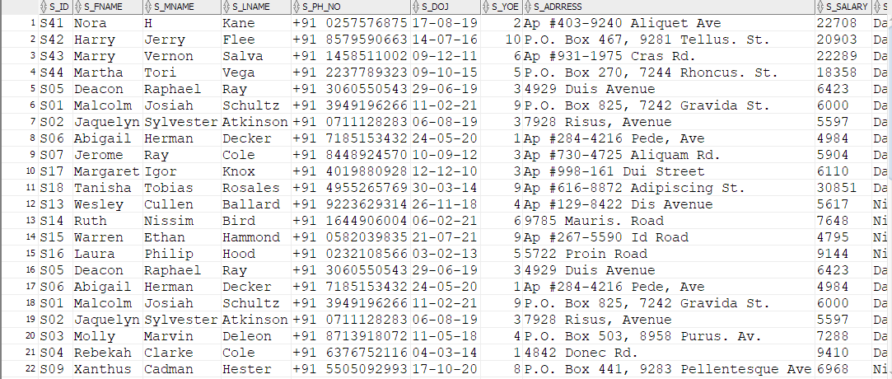

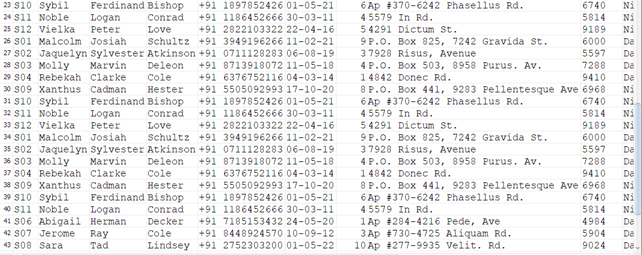

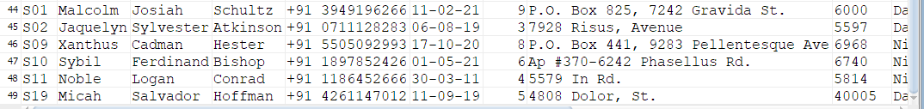

**2. Display the jobtype of all the staff members**

SELECT jobtype.j_id,jobtype.j_name, staff.s_id

FROM jobtype

INNER JOIN staff ON jobtype.j_id=staff.j_id;

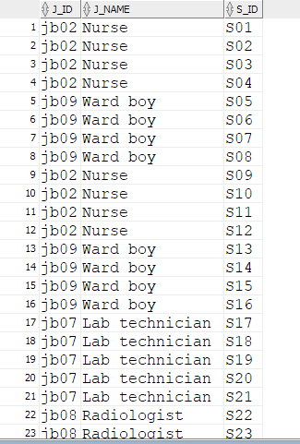

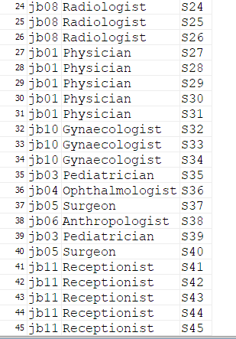

**3. Display patient name who has been prescribed the prescription.**

SELECT patient.p_fname, prescription.pr_id

FROM patient

LEFT JOIN prescription ON patient.p_id = prescription.p_id

ORDER BY patient.p_fname;

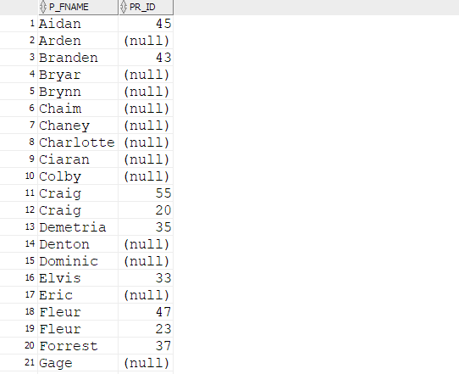

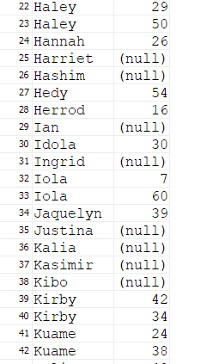

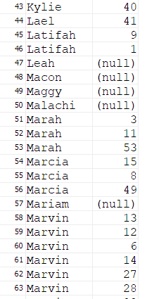

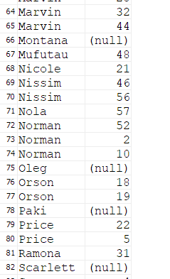

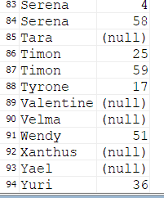

**4.Retrieve staff id and staff name assigned to the rooms.**

SELECT room.r_no, staff.s_id, staff.s_fname

FROM room

RIGHT JOIN staff ON room.s_id=staff.s_id

ORDER BY room.s_id;

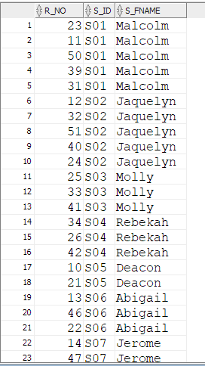

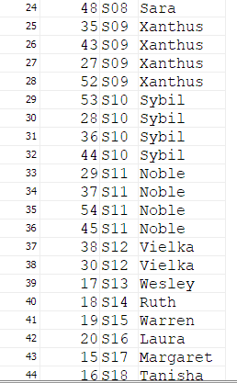

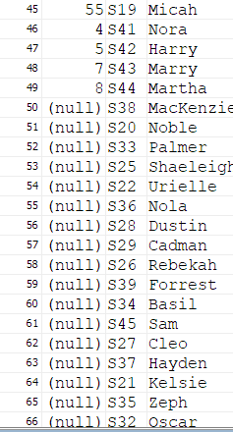

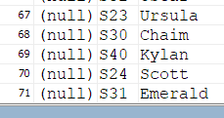

**5. Retrieve the test name prescribed to the patients**

SELECT test.t_name, prescription.pr_id

FROM test

INNER JOIN prescription ON test.pr_id = prescription.pr_id

ORDER BY test.t_name;

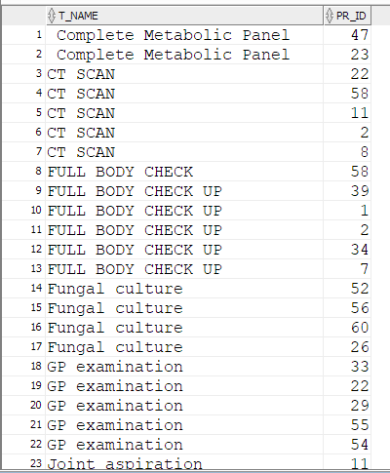

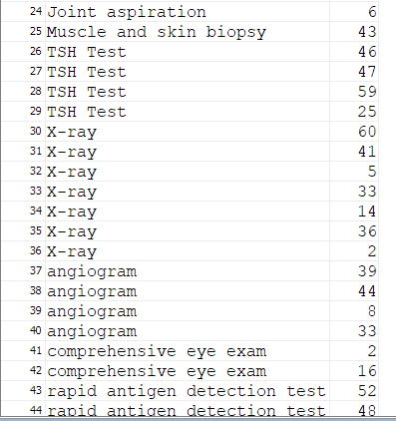

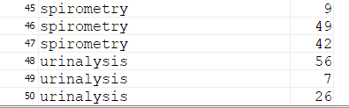

**6.Retrieve patient names of each prescription id.**

SELECT patient.p_fname, prescription.pr_id

FROM patient

FULL OUTER JOIN prescription ON patient.p_id=prescription.p_id

ORDER BY patient.p_fname;

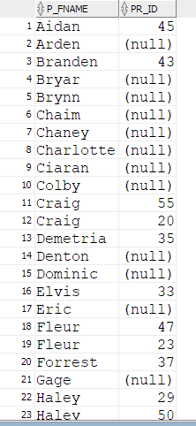

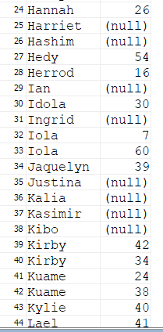

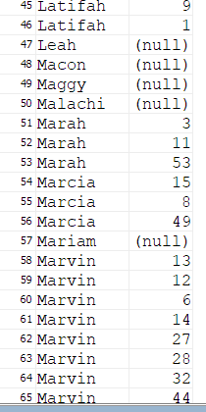

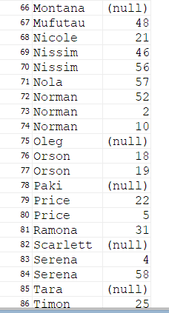

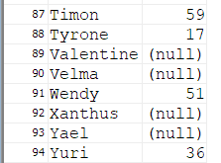

**7.Display all the test name , test date and their respective prescription date**

SELECT test.t_name, test.t_date,prescription.pr_date

FROM test

FULL JOIN prescription

ON test.pr_id=prescription.pr_id;

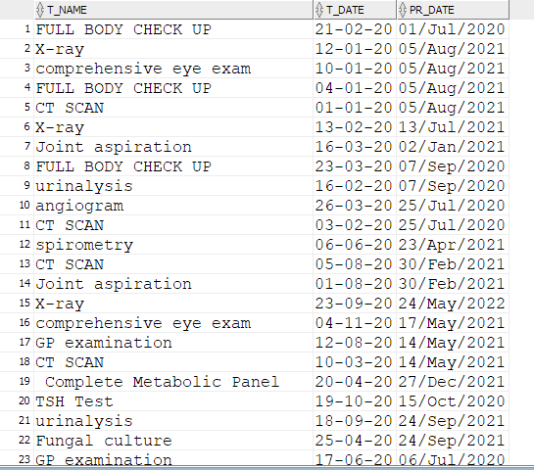

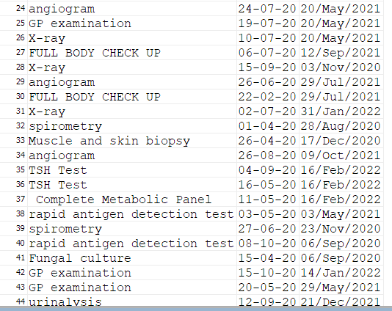

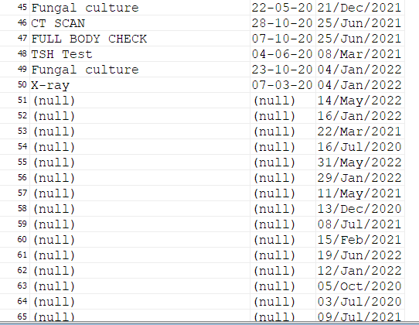

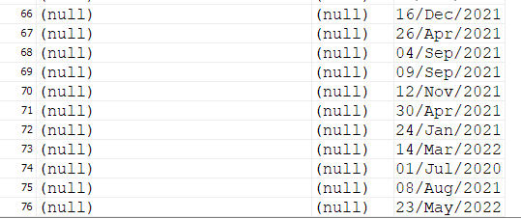

**8.Display the staff id who prescribed the test**

SELECT test.t_name, prescription.s_id

FROM test

INNER JOIN prescription ON test.pr_id = prescription.pr_id

ORDER BY test.t_name;

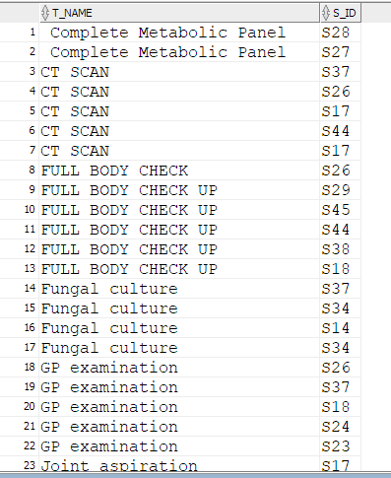

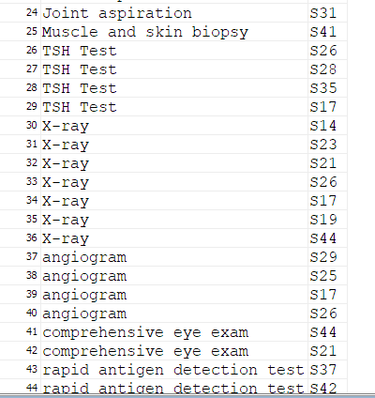

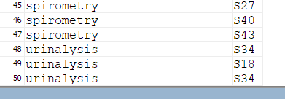

**9.Display the record id ,bed number and floor number whose room number is 2**

SELECT rec_id,bed_no,r_no,r_floorno

FROM patient_record

NATURAL JOIN room

WHERE r_floorno=2;

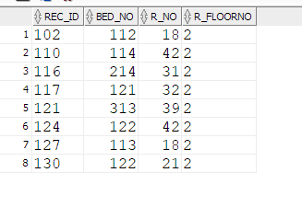

**10.Retrieve the insurance company name of the patients**

SELECT insurance.i_name, patient.p_id

FROM insurance

INNER JOIN patient ON insurance.i_id = patient.p_id

ORDER BY insurance.i_name;

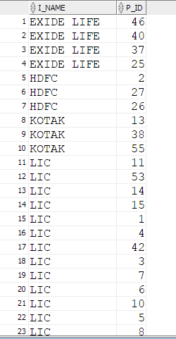

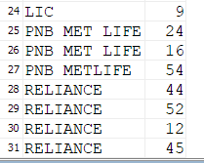

**5. ARITHMETIC AND LOGIC OPERATIONS**

**1] Display patient information who has undergone test FULL BODY CHECK UP in month of january**

select p.p_id, p.p_fname, p.p_address

from patient p, prescription pr, test t

where p.p_id=pr.p_id AND pr.pr_id=t.pr_id

AND t.t_name like '%FULL BODY CHECK UP%'

AND t.t_date like '%-01-%';

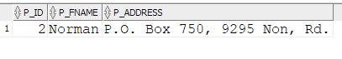

**2]Display patient details who are diagnosed with Pain in joints**

select p.p_id , p.p_fname , p.p_gender

from patient p , prescription pr

where p.p_id=pr.p_id

AND pr.diagnosis like '%Pain in joint%';

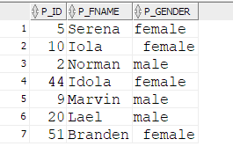

**3] Display Ophthalmologist and Surgeon name and salary by giving 10% bonus**

select s.s_fname, (1.1*s.s_salary)

from staff s, jobtype j

where s.j_id=j.j_id

AND (j.j_name like '%Ophthalmologist%' OR j.j_name like '%Surgeon%');

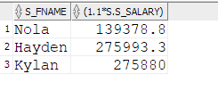

**4]Display name and salary of staff members name starting with H and salary>200000**

select s.s_fname, s.s_salary from staff s where

s.s_fname like '%H%'

OR s.s_salary>200000;

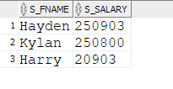

**5] Display the patient details who got admitted in room number 23,24 and 25**

select p.p_fname, p.p_address

from patient p, patient_record pr

where p.p_id=pr.p_id

AND pr.r_no IN (23,24,25);

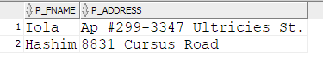

**6] Display staff information whose salary ranges between 30k - 35k**

select s.s_fname,s.s_salary

from staff s

where s.s_salary

BETWEEN 30000 AND 35000;

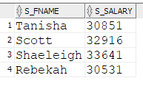

**7] Display test name prescription id whose will get their test results between 16 april 2020 and 25 april 2020**

select t.t_name, t.pr_id

from test t

where t.tr_date

BETWEEN '16-04-2020' AND '25-04-2020';

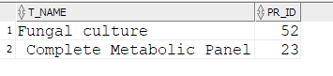

**8] Display names of staff members who either is assigned to room or does tests.**

select s.s_fname

from staff s, room r

where s.s_id=r.s_id

UNION

select s.s_fname

from staff s, test t

where s.s_id=t.s_id;

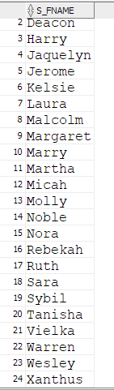

9] Display name of female patients who have insuarance amount>100000

select p.p_fname

from patient p

where p.p_gender='female'

INTERSECT

select p.p_fname

from patient p, insurance i

where i.i_amount>100000

and i.i_id=p.i_id;

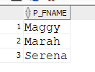

**10] Display Doctors name who diagnosis the patient with visual error and have experience more than 5 years**

select s.s_fname

from staff s, prescription pr

where s.s_id=pr.s_id

AND pr.diagnosis=' Visual refractive errors'

INTERSECT

select s.s_fname

from staff s, jobtype j

where s.j_id=j.j_id

AND s.s_yoe>5;

